# Practical 1: Write a program to get frequency count of all symbols in a file

## Code:

#include<iostream>

#include<fstream>

using namespace std;

int main()

{

char ch;

int i, count=0;

char arr[26] = {'a','b','c','d','e','f','g','h','i','j','k','l','m','n','o','p','q','r','s','t','u','v','w','x','y','z'};

char arr2[26] = {'A','B','C','D','E','F','G','H','I','J','K','L','M','N','O','P','Q','R','S','T','U','V','W','X','Y','Z'};

ifstream ifile;

ifile.open("kaustubh.txt");

while(ifile>>ch)

for(i=0;i<26;i++)

if(arr[i]==ch || arr2[i]==ch)

count++;

cout<<" Frequency : "<<count;

return 0;

}

## Input File:

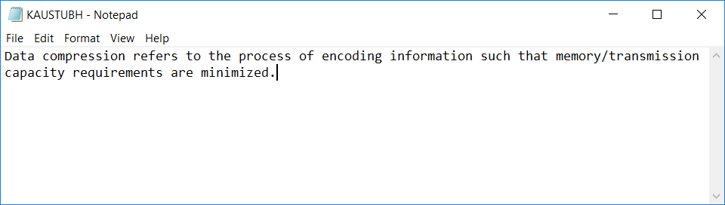

## Output:

